UID EXPERIMENT 5

ROLL NO:240701495 NAME: SHERIN KATHERINA D

Task Analysis
Task Analysis is the process of breaking down a user's interactions with a system into smaller, manageable steps to understand how users achieve their goals. It helps in identifying user needs, pain points, and areas for improvement.

Key Aspects of Task Analysis:
• Understanding what tasks users perform.
• Identifying the sequence of actions required to complete a task. • Analysing user pain points and inefficiencies.
• Defining requirements to improve the user experience.

User Flow
User Flow is a visual representation of how users navigate through an application to complete a specific goal. It shows the steps users take from the entry point to the final action.

Key Aspects of User Flow:
• Represents decision-making paths (e.g., what happens if a user cancels a form).
• Maps different navigation possibilities (e.g., alternative ways to reach the goal).
• Shows how users move between screens.
USER FLOW OF ONLINE SHOPPING APP
Main Flow
START → Open App → Login / Sign Up → Login Successful? → Yes → Home Page → Browse Categories / Search Products → Select Product → Product Available? → Yes → Add to Cart → View Cart → Payment? → Online Payment → Payment Confirmation → Shipping Details → Order Confirmation → END
Alternative Paths
Login Successful? → No → Error Message → Login / Sign Up
Product Available? → No → Show Out of Stock → Browse Categories / Search Products
Payment? → Cash on Delivery → Shipping Details → Order Confirmation
USER FLOW OF ONLINE SHOPPING APP
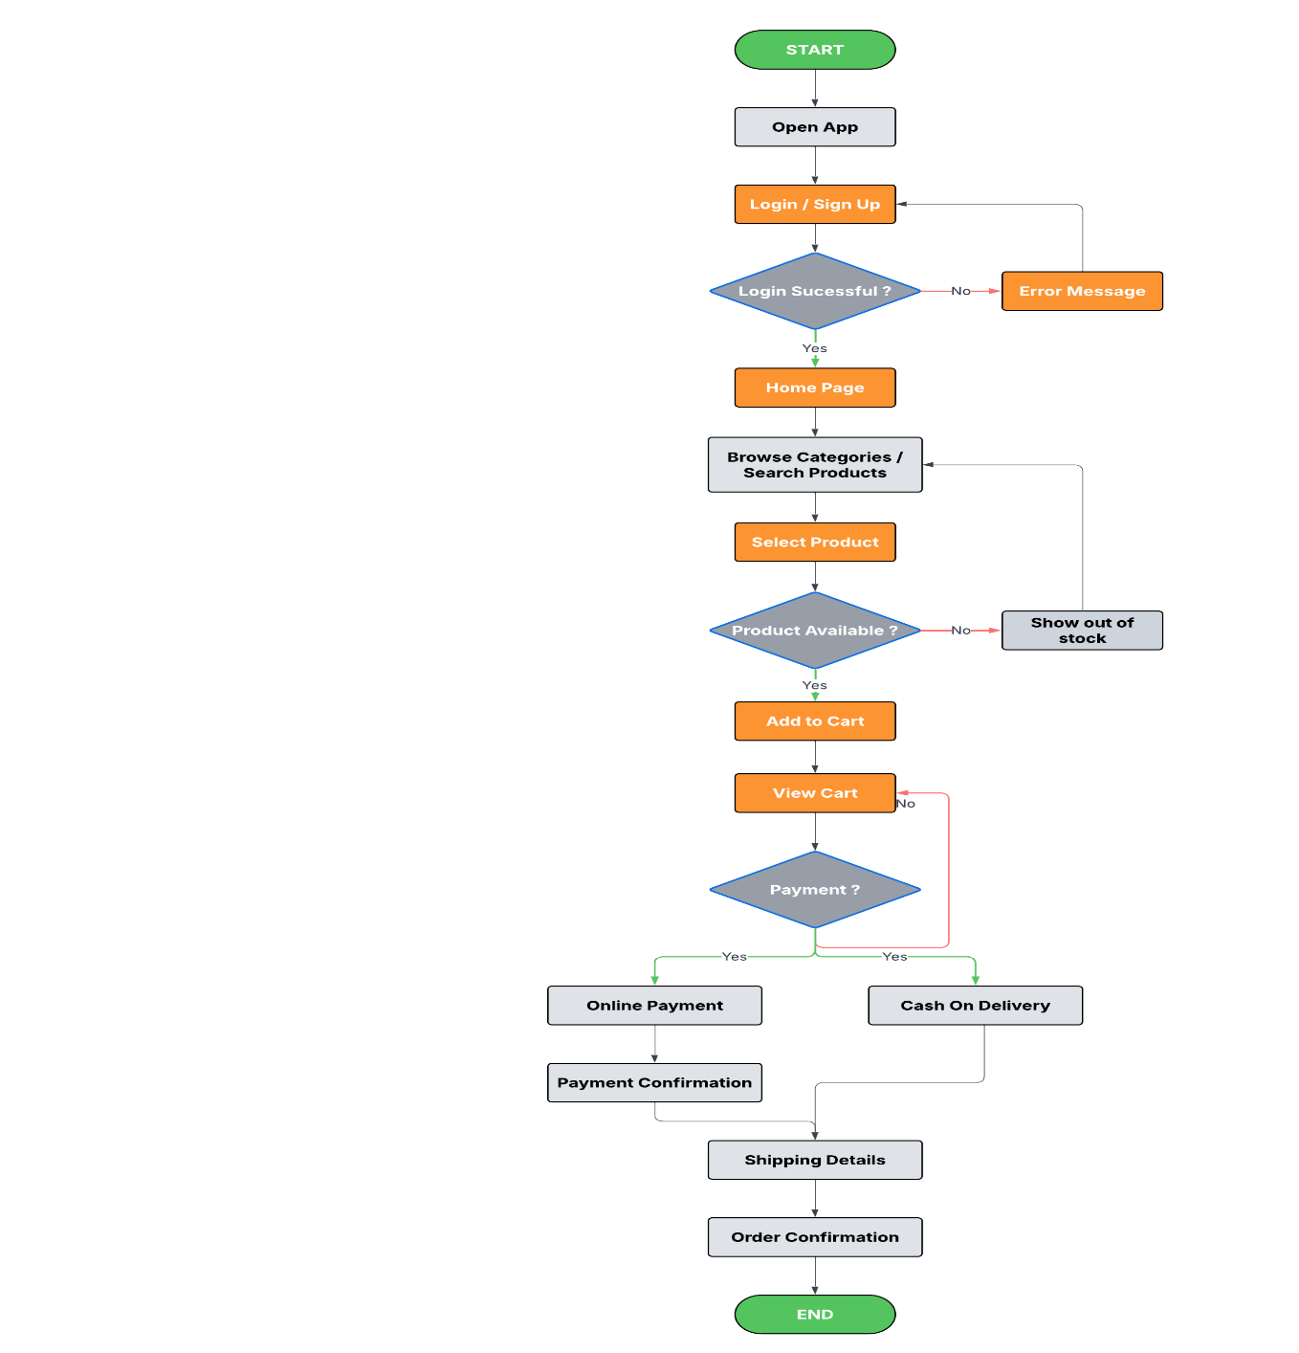

User Flow Description – Online Shopping App

Step 1: Start
• The user opens the online shopping application.
• The system displays the main entry interface where the user can begin using the platform.

Step 2: Login or Sign Up
• The user is given options to log in or sign up.
• If the user already has an account, they log in to continue.
• If the login details are incorrect, an error message is displayed, and the user can retry logging in.

Step 3: Home Page
• After successful login, the user is directed to the home page.
• The home page displays various product categories and a search option.

Step 4: Browse Categories or Search Product
• The user browses through available product categories or searches for a product using the search bar.
• The system displays a list of products related to the selected category or search query.

Step 5: Select Product
• The user selects a product from the product list.
• The application shows detailed information about the selected product.

Step 6: Product Availability Check
• The system checks whether the selected product is available in stock.
• If the product is out of stock, a message is displayed informing the user.
• If the product is available, the user can proceed to add the item to the cart.

Step 7: Add to Cart
• The user adds the selected product to the shopping cart.
• The cart stores the selected items for purchase.

Step 8: View Cart
• The user reviews the products added to the cart.
• The cart displays the list of products, quantity, and total price.

Step 9: Payment Method Selection
• The user chooses a payment method to complete the purchase.
• The available options include:
- Online Payment
- Cash on Delivery (COD)

Step 10: Payment Confirmation (Online Payment Only)
• If the user selects online payment, the system verifies the transaction.
• Once the payment is successful, a payment confirmation message is displayed.

Step 11: Shipping Details
• The user enters delivery information such as address, contact details, and preferred delivery location.

Step 12: Order Confirmation
• The system displays a summary of the order including product details and delivery information.
• The user confirms the order.

Step 13: End of Process
• The order is successfully placed.
• The user can track the order status or continue shopping for more products.
WIREFRAME
